1. **(20 pts) Present a method to verify the normality of a data set. Present some examples**.

The hypotheses used are:

* Ho: The sample data are not significantly different than a normal population.
* Ha: The sample data are significantly different than a normal population.

**W/S Test for Normality**:

A fairly simple test that requires only the sample standard deviation and the data range.

$$q=\frac{w}{s}$$

where q is the test statistic, w is the range of the data and s is the standard deviation.

The W/S test uses a critical range. IF the calculated value falls WITHIN the range, then accept Ho. IF the calculated value falls outside the range then reject Ho.

Example 1: The sample of 17 village’s population density, level of significane = 0.05

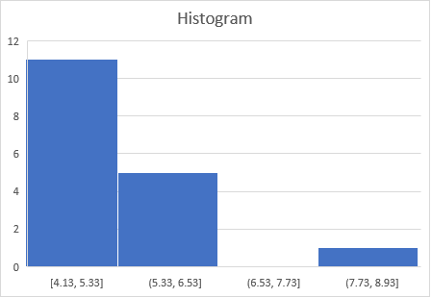

Standard deviation (s) = 0.866

Range (w) = 3.6 n = 17

q= 3.6/0.866 = 4.16

qcritical Range= 3.06 to 4.31

Since 3.06 < q=4.16 < 4.31, then we accept Ho. The sample data are not significantly different than a normal population.

Example 2: The sample of 20 student’s heights, level of significane = 0.05

Standard deviation (s) : 8.9

Range (w): 33 n=20

q = 33/8.9 = 3.7

qcritical Range=3.18 to 4.49

Since 3.18 < q=3.7 < 4.49, then we accept Ho. The sample data are not significantly different than a normal population.